DriverPass App
Business Requirements Document (BRD)
Matthew Pool
Southern New Hampshire University
08/15/2023

Business Requirements Document (BRD)

System Components and Design

Purpose
- This project is for one of our clients, DriverPass, who noticed that there are few tools to train students to pass the driving tests at the local Department of Motor Vehicles (DMV), as 65% of those attempting the test fail. DriverPass would like to provide students with access to up-to-date online practice exams and on-the-road training to better prepare them for driving tests at their local DMV. The proposed cloud-based system will allow customers to register for 2-hour driving sessions, in-person lessons, and online practice tests that follow the latest DMV compliance guidelines.

System Background

Business Model
- Purpose: Help students pass their driving test, as 65% of attempts are unsuccessful due to little availability of tools to properly train students.
- Availability: 10 cars with 1 driver each
- Package #1: 6 hours in a car with a trainer
- Package #2: 8 hours… AND in-person lesson explaining DMV rules/policies
- Package #3: 12 hours… AND in-person lesson… PLUS online class
  - Example: 12-hour session split up into six 2-hour sessions
  - Note: unavailable packages will be disabled
Architectural Model
Layer 1: Presentation Tier - Front End (Web Browser UI)
- Input Form page for customer (or secretary) registration, package selection, scheduling
- Reservation page to cancel, modify, view appointments online
- Contact Us page to contact DriverPass
- Password Reset page for forgotten passwords
- Details page showing driver and student information, test progress, special needs, photos
- Admin Page: client-access page for reports, user account controls, reservation tracking, modification, and IT Officer interface for maintaining and modifying the system
Layer 2: Application Tier – Web/App Server (Business Logic)
- DriverPass requires a web-based (cloud) system to cover security, backup, and other technical platforms
- Cloud server handles communications and processes information between the data layer and user’s device
- Cloud provider serves web pages to customers and other users and handles web application logic
Layer 3: Data Tier – Database Storage Server
- ACID-compliant SQL Server: processes query commands related to stored data
- Customer data: first name, last name, address, phone number, email address
- Driver data: first name, last name, address, phone number, employee ID
- Appointment data: customer name, driver name, appointment date and time
- Encrypted data: login credentials, access permissions, billing information, security code
- DMV data: compliance rules, policies, sample questions

User Functionality
- Customer Functionality
  - register or log in to / log out of account
  - register for one of three packages, specifying date and time
  - cancel or modify appointments online
  - see driver’s identification information (total of 10 cars with 1 driver each)
  - password reset online (for forgotten account password)
  - contact DriverPass
  - view online test progress, driver notes, student information, special needs, driver photo, and student photo
- Secretary Functionality
  - register or log in to / log out (password reset) of account, on behalf of Customer
  - Register or modify package ,on behalf of Customer
- Client (Owner) Functionality
  - log in to / log out of account
  - download reports and some information to work on at home
  - full access to all accounts to reset password or block user access from former employees
  - track who registers/cancels reservations and who modifies each last
  - print activity reports of user activity
  - contact student
- IT Officer Functionality
  - log in to / log out of account
  - modify system, including updating via pull request to DMV
- DMV Functionality
  - sends update notification to system when available
- Statistics & Graphs
  - amount of people who completed on time
  - average test time
  - amount of people who pass/fail
  - mean/average grades of students

Requirements

Nonfunctional Requirements

Performance Requirements
- System should run as a web-based application accessible via desktop or mobile devices
- Response time for loading pages and processing user actions should be less than 2 seconds
- Appointment availability should be updated in “real-time” to show the latest driving session availability

Platform Constraints
- System should run on all major desktop and mobile platforms, including Windows, macOS, Linux, iOS, and Android
- System should be accessible on all major web browsers, including Chrome, Safari, Firefox, Edge, and Opera
- Back-end requires a cloud-based database to store customer information, driver details, appointments, and other data securely
- Back-end requires a web/app server to serve pages to user’s browser/device

Accuracy and Precision
- User accounts will require unique usernames and passwords with rules, including mixed capitalization, at least one special character and numeric digit, and must be at least 8 characters long.
- Authenticated users will have access to different functionality based on associated authorization rules
- The username input will not be case-sensitive, but the password input will be case sensitive to allow for greater security
- The system should notify the admin of any critical issues, such as security breaches or technical issues like server crashes or other relevant concerns

Adaptability
- System should allow administrative users to add, remove, or modify user accounts without changing underlying code
- System should be designed with a modular structure to accommodate platform updates and future changes, without causing severe downtime
- IT admin should have full access to system settings, user accounts, and database access
- Future updates will allow customized packages with functionality to add or remove modules by the developer or systems analyst
- DMV connected to update new compliance rules, policies, and sample questions and to trigger notification for the client
- System will be automatically backed up on a regular basis to a secondary cloud-storage to allow full system recoverability in the chance of system data loss or failure

Security
- User will need to use their associated username and password, which must consist of mixed capitalization, at least one special character and numeric digit, and be at least 8 characters long
- Typed passwords will be hashed (and salted) and compared to the stored hashed password in the database
- Forgotten passwords can be reset by clicking the “Forgot Password” link underneath the password entry textbox
- Connection between client and server should utilize SSL/TLS encryption to protect data exchange via HTTP/HTTPS, respectively
- After 6 unsuccessful login attempts, the account will be locked, and a password reset will be required, in order to prevent potential hacking attacks like brute force
- Advanced Encryption Standard (AES) will be used to encrypt the database data at rest

Functional Requirements
- The system must allow customers to register for driving sessions from three different packages and specify date, time, and pickup/drop-off location
- The system must allow customers to cancel or modify appointments
- The system must validate user credentials when logging in, using the associated username and password stored in the system, before allowing a user to add a package
- The system must have a “Password Reset” link to reset a forgotten password, using the user’s email address or phone number
- The system must display driver identification information, available cars, and assigned drivers
- The system must display online test progress, driver notes, student information, special needs, driver photos, and student photos
- System must provide statistics and graphs based on test history of user database

User Interface

- Compatibility & Controls
  - HTML/CSS, such as buttons, text fields, radio buttons, etc., will be used to ensure compatibility with updates and modern platforms (Windows, macOS, Linux, iOS, or Android with Chrome, Safari, Firefox, Edge, or Opera)
  - JavaScript will be utilized to allow for interactive controls and widgets, such as a pop-up calendar for scheduling appointments, dialogs, and other dynamic behavioral elements

- Design & Layout
  - All Pages: must include a centered company logo at the top of each page
  - User Interface: Intuitive and consistent interface to be used by students (customers) or secretary and administrative users (IT Officer and owner)

  - Details Page (mock-up):
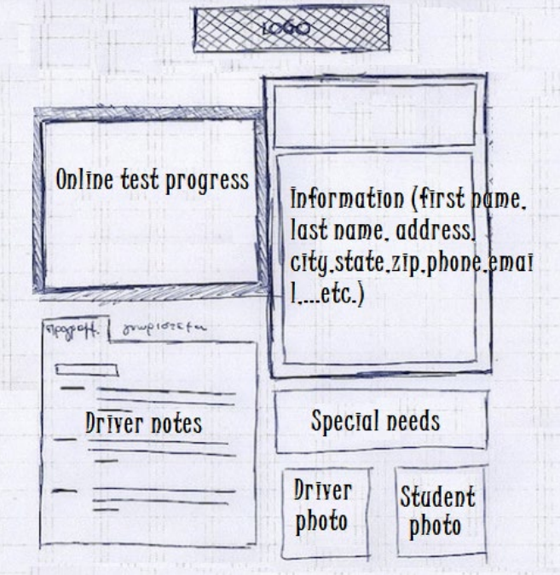
  - Online Test Progress: customer’s available tests, tests in progress, completed tests
    - Fields: “Test Name”, “Time Taken”, “Score”, “Status”
      - “Status” States: NOT TAKEN, IN PROGRESS, FAILED, PASSED
  - Driver Notes:
    - Fields: “Lesson Time”, “Start Hour”, “End Hour”, “Driver Comments”
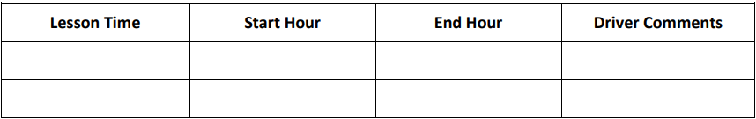
- Functionality
  - Customer UI
    - Register Account: Upon clicking the “Sign-Up” link (at the top-right of all pages if user not logged in) to view the sign-up form, provide requested information consisting of first name, last name, address, city, state, zip, phone number, email address, username, and password (twice), and click the “Submit” button. A pop-up message will confirm account registration or notify user of any issues, including trying to register an existing username or failing to follow all password rules appropriately.
    - User Login: A “Log In” (or “Log Out”) link will appear underneath the “Sign Up” link and upon clicking will display the login form. After entering a username and password, the typed password is hashed and compared to the hashed password in the database matching that username (primary key). A pop-up message will confirm a successful login or notify user of any issues.
    - Input Form: Click “Pick a Package” to open Input Form page and view the details of the available packages, click the appropriate package’s radio button, and click the desired date from the pop-up calendar, and click the “Submit” button. A pop-up message will confirm appointment or notify user of any issues.
    - View/Change Package: Upon clicking “Appointments” at the top-left of the Details page (not shown in the mock-up), appointments will be shown, and the user can click any appointment to see its details. The user can then click “Cancel Appointment” (which will display terms of cancelation and require a confirmation from the user), “Change Appointment” (confirmation required), or click “Done” to hide the information. If the appointment is canceled, a confirmation of the cancelation will be sent to the user’s email address on file.
    - View Driver: Clicking the driver photo on the Details page will pull up the driver’s first name, last name, phone number, and employee ID. A “Done” button can then be clicked to hide this information again.
    - Password Reset: The Student Information section of the Details page will provide a “Password Reset” link that can be clicked to allow for creating a new password (to be confirmed twice) via a link to the customer’s email address or mobile phone. The password must comply with the previously stated password rules. The user will be redirected to the Details page, upon successfully resetting their password.
    - Contact Us: Underneath the “Sign Up/Log In/Log Out” link, there will be a “Contact Us” link that the user can click, which will bring up the Contact Us page. The user must type in their preferred email address, name, and message, and then click “Submit”. A pop-up will confirm successful submission, and a “Done” button will be presented that the user can click in order to go back to the previous page.
    - View Details: User may click any of the following links to view more details (“Done” button will be displayed to go back):
      - test progress, driver notes, student information, special needs, driver photo, student photo, view statistics/graphs

  - Client (DriverPass) UI
    - Admin Interface: Once authorized via a username and password, administrators (users belonging to the “Admin” group) will be brought to an Admin page with various links and information:
      - Manage Users: Opens a page listing all usernames, each of which can be clicked to open the details of that user. Options include “Delete User”, “Modify Account”, “Block User”, “Contact Student”, “Reset Password”, and “Done”, in which an admin may change user account information or delete or block the account altogether. A pop-up confirmation will be required to process any changes.
      - View Report: Opens a page of various reports of data pulled from the database, including “User Statistics”, “Active Users”, “Accounting Data”, “Appointments”, and “User Activity”. Each has a “Print” button next to the report name to allow printing any of the reports.
      - Modify System: Includes advanced admin options for changing the code or layout of the system, removing, adding, or modifying packages, updating, and performing other various administrative tasks like S.E.O.

Assumptions
- Users are using an updated desktop or mobile device running a modern and secure operating system
- Users are using one of the major web browsers like Chrome, Safari, Firefox, Edge, or Opera, or another compatible app
- Users have a stable and reliable broadband internet connection with an average download speed of at least 5 Mbps and upload speed of at least 1 Mbps with latency no more than 100ms
- Users are familiar with basic web navigation and available operating platform to be used

Limitations
- UI design limited to elements of color and font that match DriverPass’ established aesthetic and brand
- All test data and training material presented to users must comply with up-to-date DMV regulations and may result in system downtime when updating system
- DriverPass app must pass all requirement tests by May 8th, 2023

Gantt Chart

Schedule

Task Details (magnified)
Task # | Task name | Duration  (days) | Start date | Finish date | Owner | Dependency
1 | Collect Requirements | 14 | 1/22 | 2/4 | Team
2 | Create Use Case Diagrams | 8 | 2/11 | 2/18 | Team | 1
3 | Build Activity Diagrams | 8 | 2/15 | 3/9 | Team | 1
4 | Research UI Design | 9 | 2/27 | 3/7 | Toni & Clark
5 | Build Class Diagram | 9 | 3/1 | 3/9 | John | 2
6 | Get Customer Approval | 2 | 3/10 | 3/11 | Team | 5
7 | Build Interface | 12 | 3/12 | 3/24 | Team | 6
8 | Link DB to Interface | 9 | 3/24 | 4/3 | Team | 7
9 | Build Business Logic | 22 | 4/5 | 4/27 | Team | 8
10 | Test System | 12 | 4/27 | 5/7 | Team | 9
11 | Deliver System | 2 | 5/8 | 5/9 | Team | 10
12 | Sign-off Meeting | 2 | 5/9 | 5/10 | Team | 11

